ITP 4909 Assignment

Chan Pak Lam 200074680

1. Shopper

Member

Staff member

External payment gateway

1. View clothes

Register member

Make order

Check E-Coins balance

Redeem E-Coupon

Check order history

Adjust E-Coin

Update order status

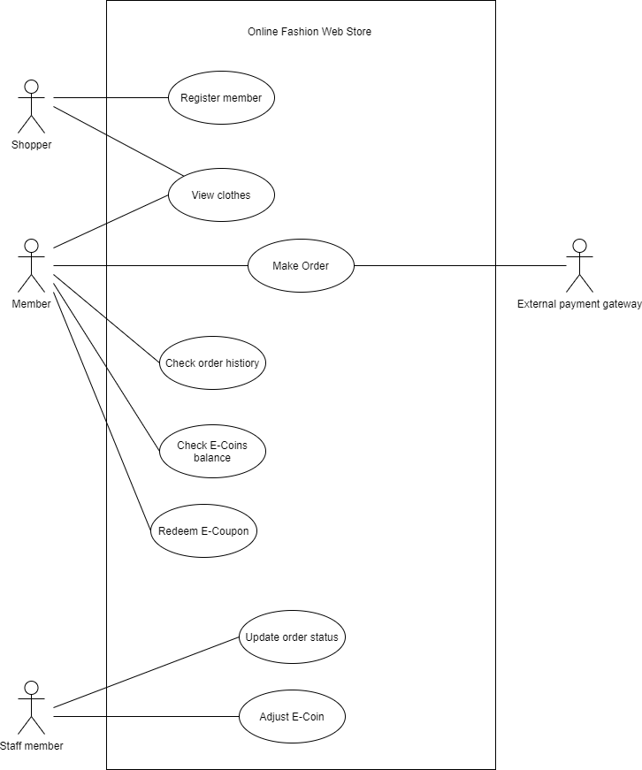

4.

|  |  |
| --- | --- |
| Actor name: | Shopper |
| Description: | A Shopper can use OFWS to view clothes and register as a member. |

|  |  |
| --- | --- |
| Actor name: | Member |
| Description: | A Member can use OFWS to view clothes, make an order, check E-Coin balance, redeem E-Coupon and check order history after logging in his/her account. |

|  |  |
| --- | --- |
| Actor name: | Staff member |
| Description: | The staff member can use OFWS to update the order status of an existing order made by a member and adjust the E-coins for members. |

|  |  |
| --- | --- |
| Actor name: | External payment gateway |
| Description: | The External payment gateway is responsible for receiving the payment amount together with the credit card details of an order and process the transaction. It is also responsible for sending an approval code back to OFWS after successful approval of the credit card payment. |

5.

|  |  |
| --- | --- |
| Use case name: | Register member |
| Use case ID: | RM-100 |
| Actor(s): | Shopper |
| Description: | The shopper enters their first name, last name, email address, and password. The system sends a confirmation email back to the shopper if registration is successful. |

|  |  |
| --- | --- |
| Use case name: | View clothes |
| Use case ID: | VC-200 |
| Actor(s): | Shopper, Member |
| Description: | The user selects a category displayed by the system. The system displays a list of clothes that match the category. The user selects a piece of clothing. The system displays a clothing page with detailed information and multiple images of it. |

|  |  |
| --- | --- |
| Use case name: | Make order |
| Use case ID: | MO-300 |
| Actor(s): | Member, External payment gateway |
| Description: | The member put the clothes to be purchased in the shopping cart and checkout. The member can choose to input a discount code. The member enters the shipping and billing address. The member enters credit card information. The system displays the order summary with an order number to the member upon successful payment. |

|  |  |
| --- | --- |
| Use case name: | Check order history |
| Use case ID: | CH-400 |
| Actor(s): | Member |
| Description: | The member selects to check order history. The system displays the order list with the order information. The member selects an order from the list to display the order details. |

|  |  |
| --- | --- |
| Use case name: | Check E-coin balance |
| Use case ID: | CB-500 |
| Actor(s): | Member |
| Description: | The member selects to check E-coin balance. The system displays the E-coin balance of the member. |

|  |  |
| --- | --- |
| Use case name: | Redeem E-Coupon |
| Use case ID: | RC-600 |
| Actor(s): | Member |
| Description: | The member selects to redeem their e-coin as coupons. The member selects to redeem which coupon. The system displays a unique ID for the redeemed coupon. |

|  |  |
| --- | --- |
| Use case name: | Update order status |
| Use case ID: | US-700 |
| Actor(s): | Staff member |
| Description: | The Staff member selects a specified member by entering the member’s email address. The system displays the detailed information and order history of the member. The Staff member enters the value of E-coin and selects to add or subtract from the member’s account. The system updates the change of balance for the member and creates a record of the E-coin adjustment. |

|  |  |
| --- | --- |
| Use case name: | Adjust E-Coin |
| Use case ID: | AE-800 |
| Actor(s): | Staff member |
| Description: | The Staff member selects to update the order status. The Staff member inputs the order number. The system displays the order details. The Staff member updates the fulfillment status of the order. |

6.

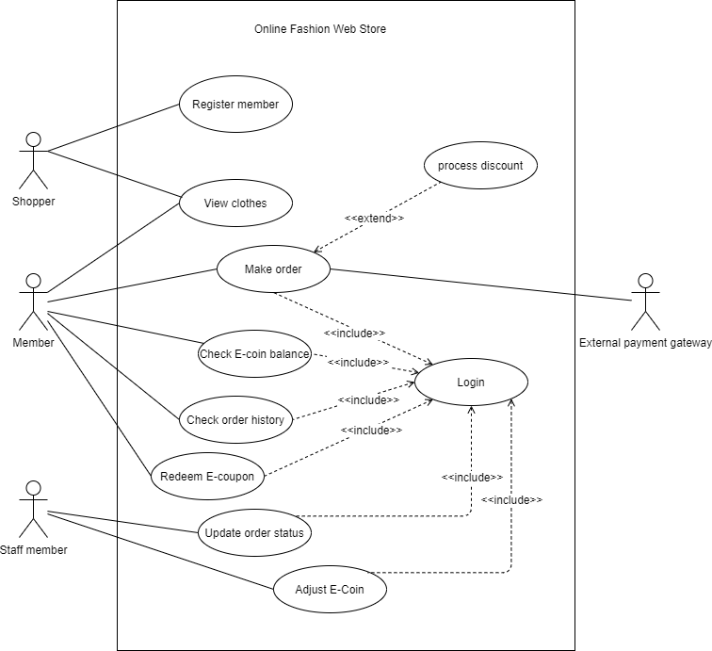

7.

|  |  |
| --- | --- |
| Use case name | Login |
| Use case ID | FU-100 |
| Brief description | User type their email address and password to login into the system |
| Pre-Conditions | Account exists |
| Flow of events | 1. User type email address and password  2. User click “login” button. |
| Alternative flows and exceptions | Step1: If user type an invalid email address or password, show error msg “Wrong email or password”. and restart use case.  Step 1: If the user has not registered as a member, invoke use case RM-100 “Register membership”. |

|  |  |
| --- | --- |
| Use case name | Register membership |
| Use case ID | RM-100 |
| Brief description | Shopper enter their first name, last name, email address and password. If successful registration, a confirmation email will send back to the shopper. |
| Primary actor | Shopper |
| Pre-Conditions | User does not have a valid account |
| Flow of events | 1. User click the “Create Account” button. 2. User input first name, last name, email address and password. 3. User click “submit” button. 4. System sends a confirmation email to user. |
| Post-Conditions | System adds new account to database |

|  |  |
| --- | --- |
| Use case name | View clothes |
| Use case ID | VC-200 |
| Primary actor | Shopper, Member |
| Brief description | User selects a category displayed by system. System shows a list of clothes that is match the category. User selects a piece of clothing. System shows a clothing page with detailed information and multiple images of it. |
| Flow of events | 1. User selects category. 2. User selects a piece of clothing. 3. System displays a clothing page with the clothes description, price, measurement and available colors and multiple images of the clothing. |
| Post-Conditions | Step2: User can get to the exact clothing quicker by entering type of clothing, size and color.  Step3: User can add the clothes to the shopping cart. |

|  |  |
| --- | --- |
| Use case name | Make order |
| Use case ID | MO-100 |
| Primary actor | Member |
| Secondary actor | External payment gateway |
| Brief description | The member can place clothes to the shopping cart and pressing the “Check Out” button. The member can choose to input a discount code. The member enters the shipping and billing address. The member enters credit card information. System displays the order summary with an order number to the member upon successful payment. |
| Pre-Conditions | User has a valid account |
| Flow of events | 1. Invoke use case VC-200 “View clothes”. 2. User click the “Check Out” button. 3. Invoke use case UC-100 “Login”, log in as a member. 4. The member enters the shipping and billing address. 5. The member enters credit card information. 6. System displays order summary with an order number to the member. |
| Post-Conditions | System updates the member’s account order history and E-coin amount. |
| Alternative flows and exceptions | Step 3. User can invoke use case PU-55 “Process discount” after logging in if the member has a VIP code or E-coupon ID to use. |

|  |  |
| --- | --- |
| Use case name | Process discount |
| Use case ID | PU-55 |
| Brief description | The member input a discount code, either a VIP code or E-coupon ID to get a discount. |
| Pre-Conditions | User has a valid VIP code or E-coupon ID on purchases over $500 |
| Flow of events | 1. User inputs VIP code. 2. User press the “submit” button. |
| Alternative flows and exceptions | Step 1. User can input an E-coupon ID instead of a VIP code if the order is 500 dollars or more than 500. |

8.

|  |  |
| --- | --- |
| **Candidate Class** | **Category** |
| Member | Role played |
| Staff | Role played |
| Clothing | Tangible |
| Order | Event |
| E-Coupon | Conceptual |
| ECoinAdjustment | Event |
| CreditCard | Tangible |
| CreditCardPayment | Event |
| ExternalPaymentGateway | Other System |

9.

|  |  |
| --- | --- |
| **Class** | **Definition** |
| Member | A member is a shopper that he/she was registered in OFWS. He/She can view clothes, make orders, check her/his E-coin balance, redeem her/his E-coin and check order history through the system. |
| Staff | A staff can update order status and adjust E-coins for members through the system. |
| Clothing | Clothing the different categories such as tops, bottoms, one-pieces, sets, outers. The attributes of this class have category, description, price, measurements and available colors. |
| Order | An order may have the order number, order date, payment status, fulfillment status and total in reverse chronological order. |
| ECoupon | E-coupon have the ID and type. It can be used to get discounts in marking an order. |
| ECoinAdjustment | E-coin adjustment the email address of the member's account that was chosen, the date, time and value of the adjustment. |
| CreditCard | The card number, holder’s name, expiry date, and CVV of the credit card. All is specifiable. |
| CreditCardPayment | Credit Card Payment specifies the credit card payment that have the approval code. |
| ExternalPaymentGateway | A platform that is use to processing of transactions received. |

10.

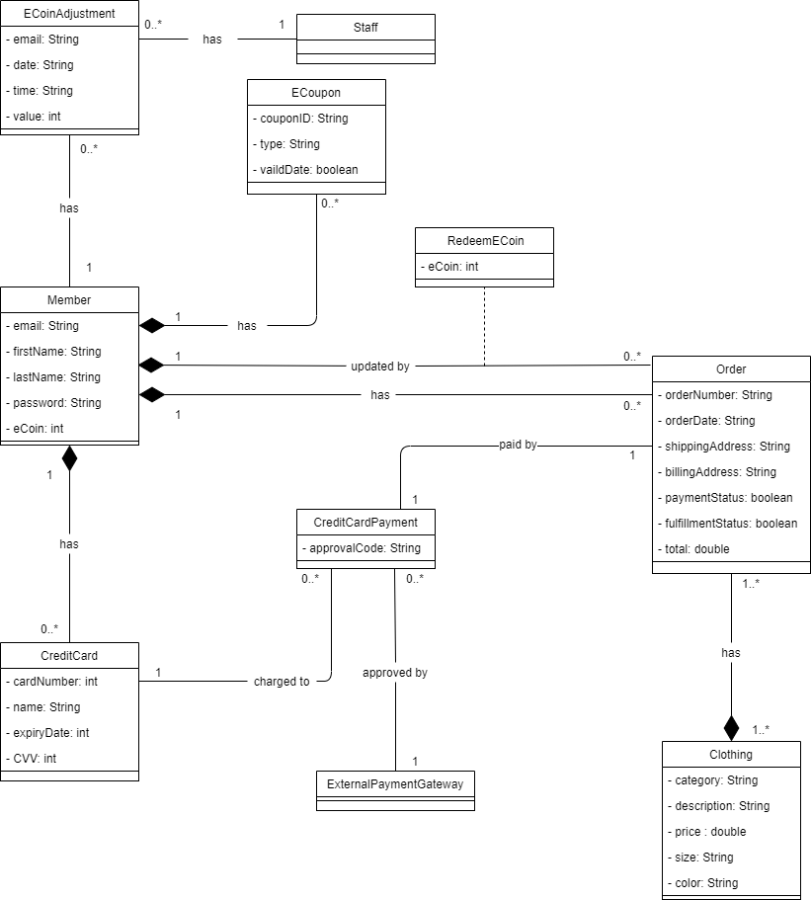

12.

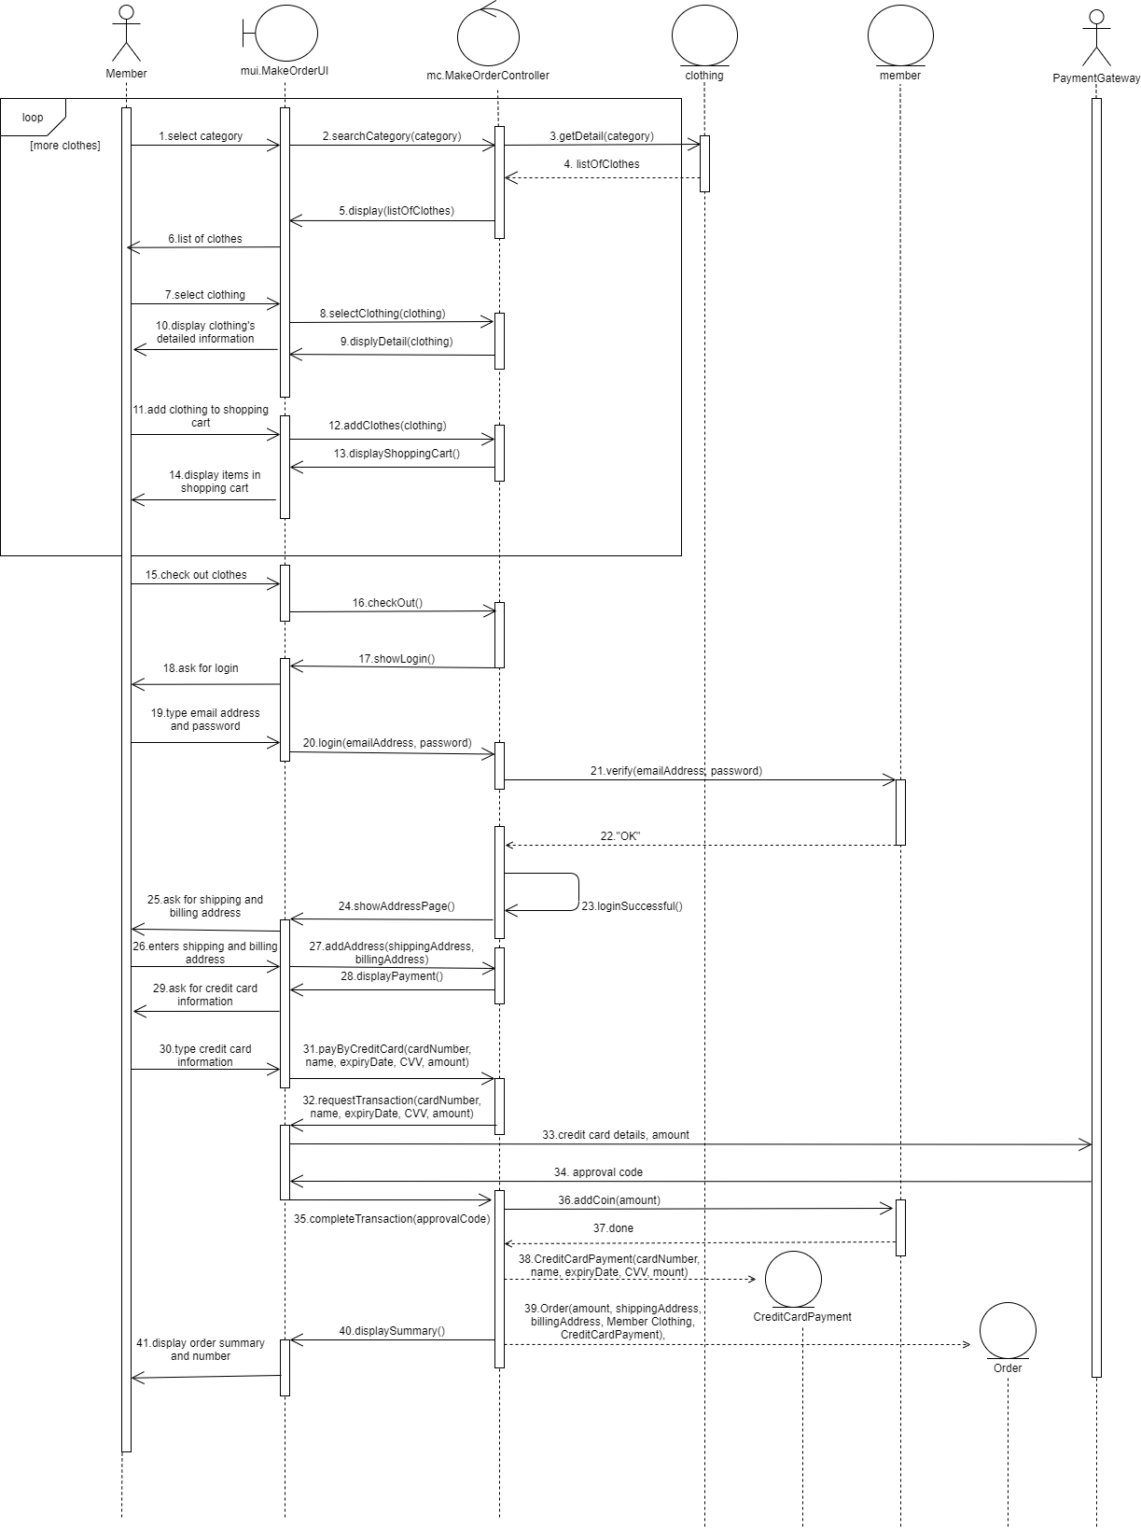

13.

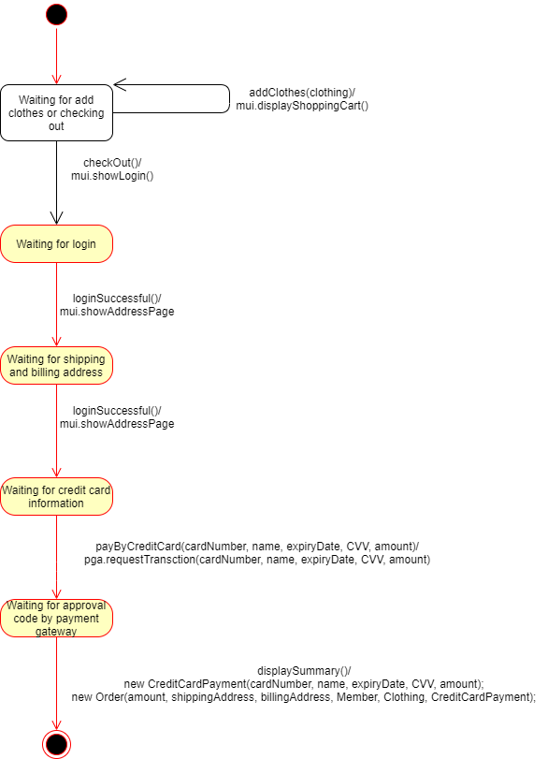

14.

